Haji Enver

Professor Skip Berry

CIS-21A-41239

9 February 2026

**Project 5 Final Comprehensive**

In this project, I plan to improve and secure my Linux system through five key actions:

1. **Disk Scaling:** I will turn the 40GB disk into a flexible storage pool (LVM) so I can separate my Ubuntu distro and other files to increase space whenever I need it.
2. **Mounting Filesystem:** I will switch to using unique IDs (UUIDs) for disks, so the system always finds the right partitions, even if the hardware changes.
3. **Home Directory Protection:** I will set up automatic checks and backups for the moved home folder to keep my personal data safe.
4. **Startup Security:** I will add special security rules to the startup file (FSTAB) to protect the system from being attacked through its storage.
5. **Shared Library Management:** I will optimize how the system runs programs by using custom settings to help files load faster.

**Action #1:** Disk Scaling.

During this stage of the project, I have a 40Gb disk and I will perform a customized installation of Ubuntu using the GNU GRUB bootloader. Instead of using the automated "erase and install" feature, I will choose Manual Partitioning to control exactly how the 40GB virtual disk was divided.

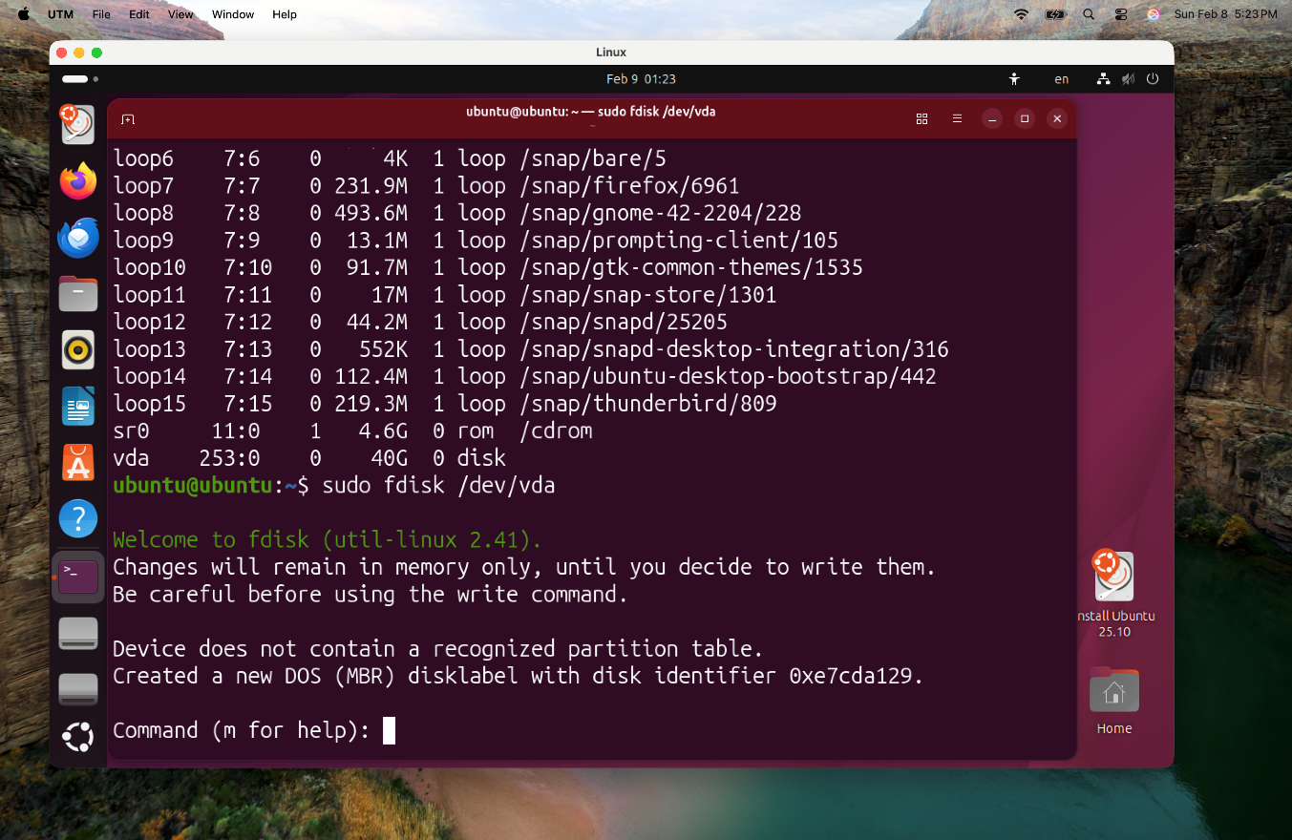

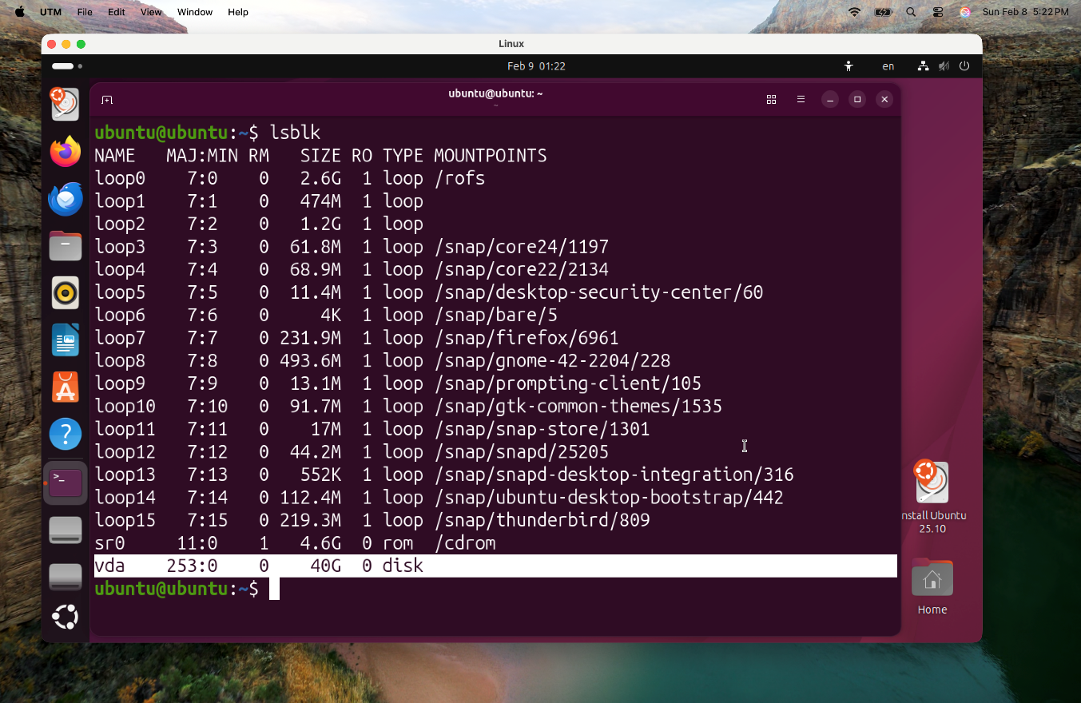

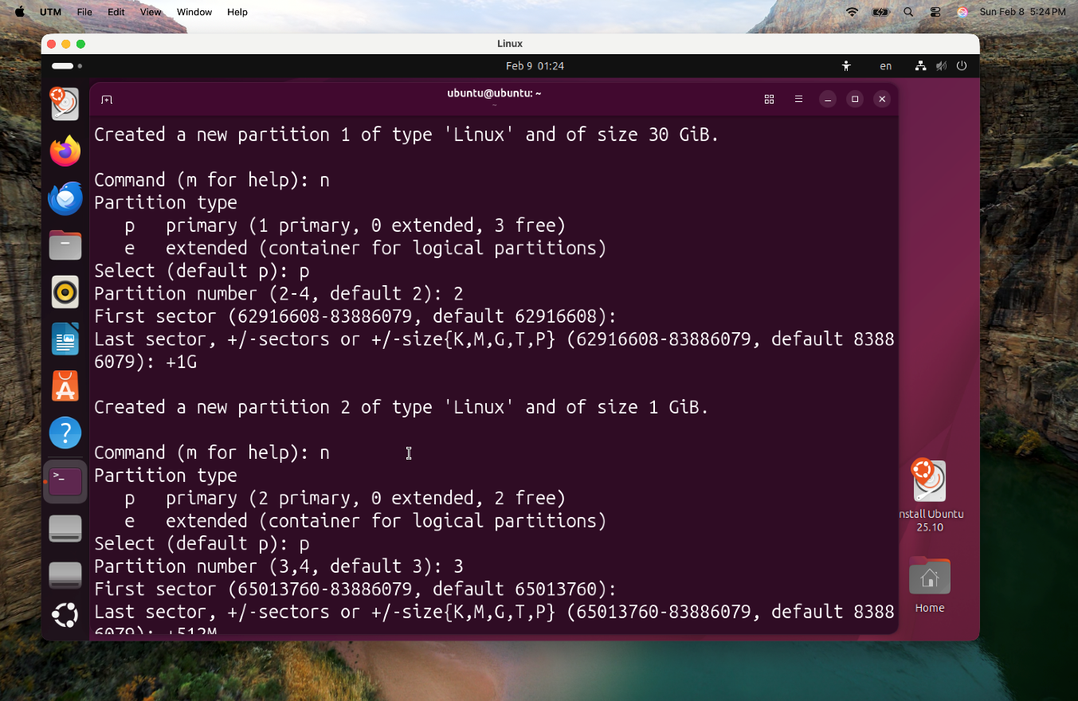

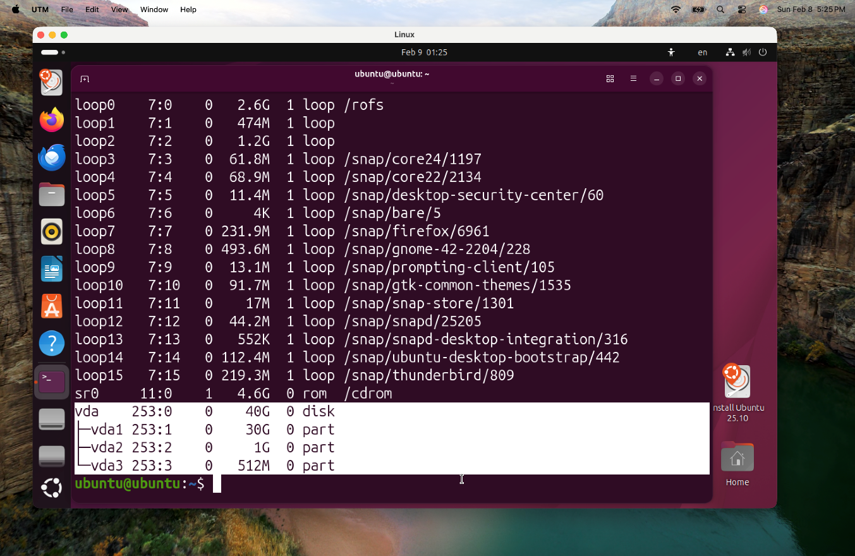

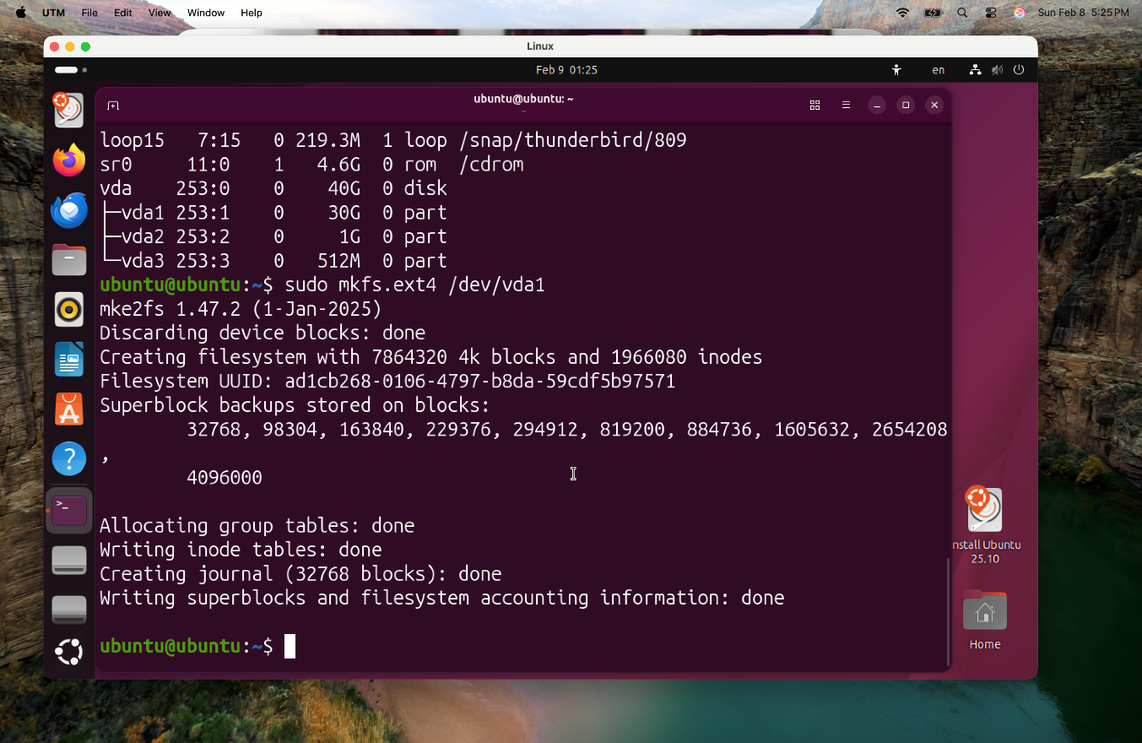

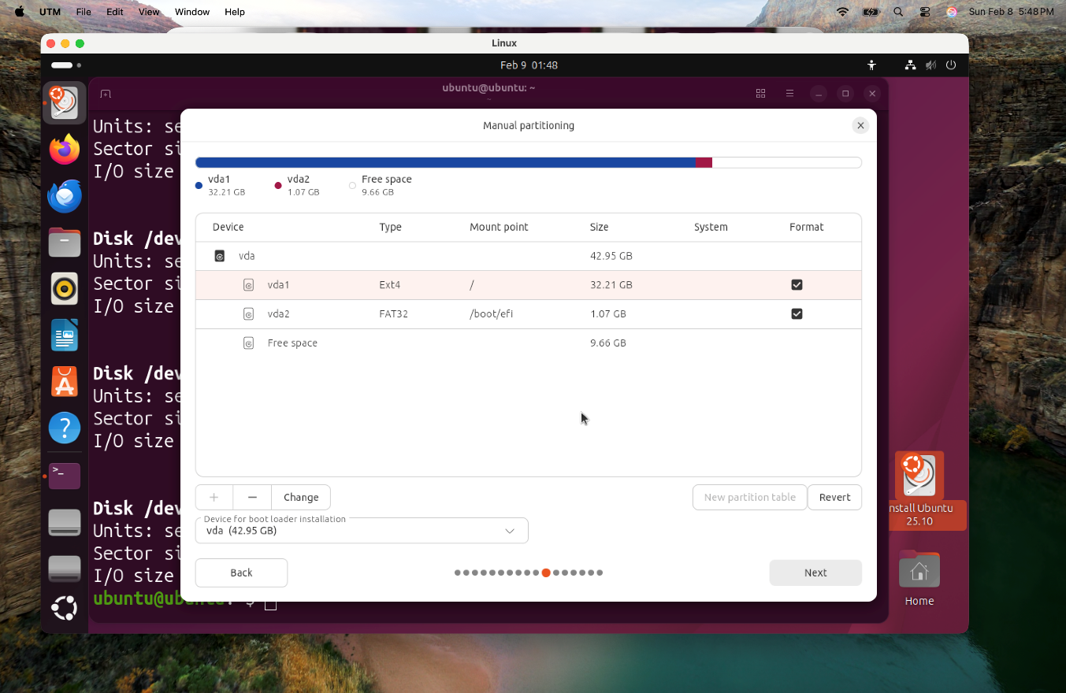

**Action #2:** Mounting filesystem.

In this step, I will create a 1 GiB partition on a secondary 10 GiB disk (vdb1), format it with the ext4 filesystem, will be mounted to /mnt/home_move/ 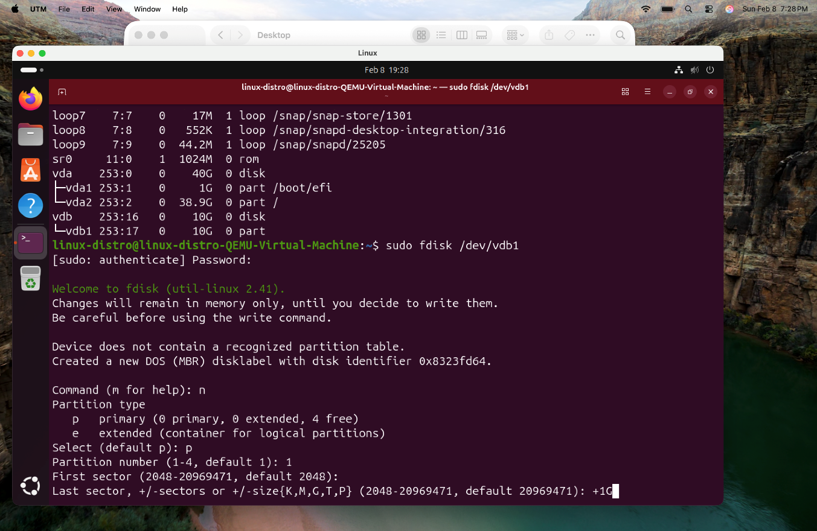

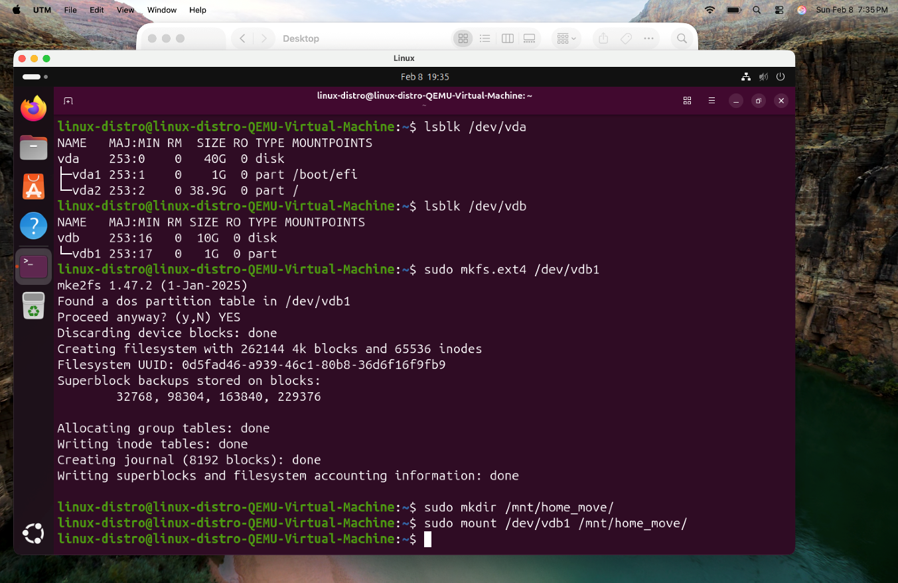

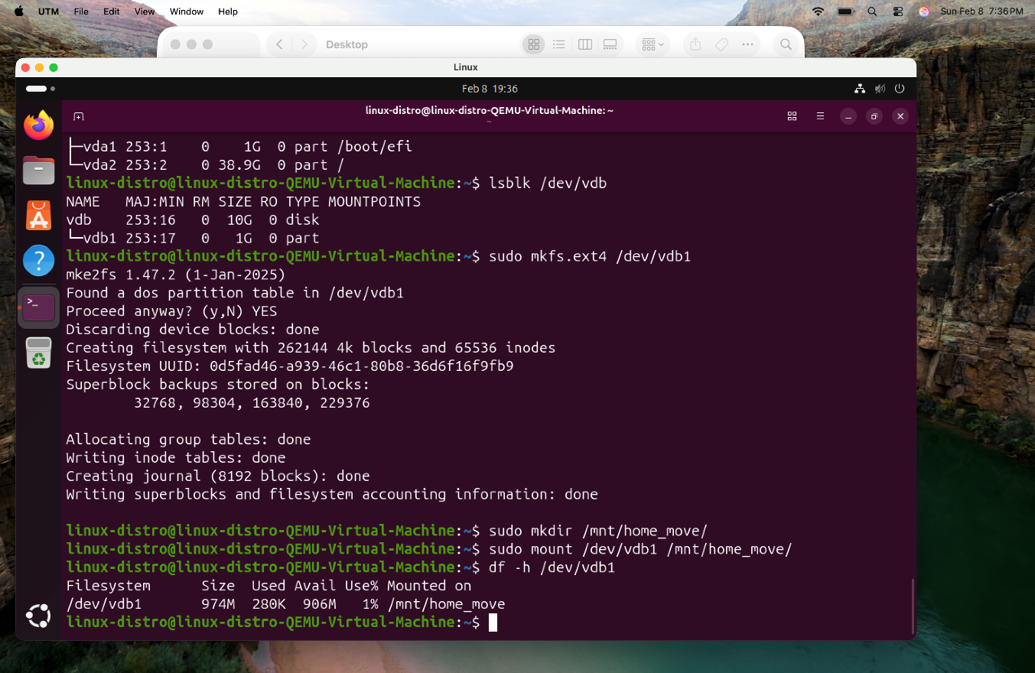

**Action #3:** Migration of Home directory.

In this step I will be using the rsync command to migrate all data from my current home directory to this new storage location. And then I will Unmount /dev/vdb1 from its temporary location.

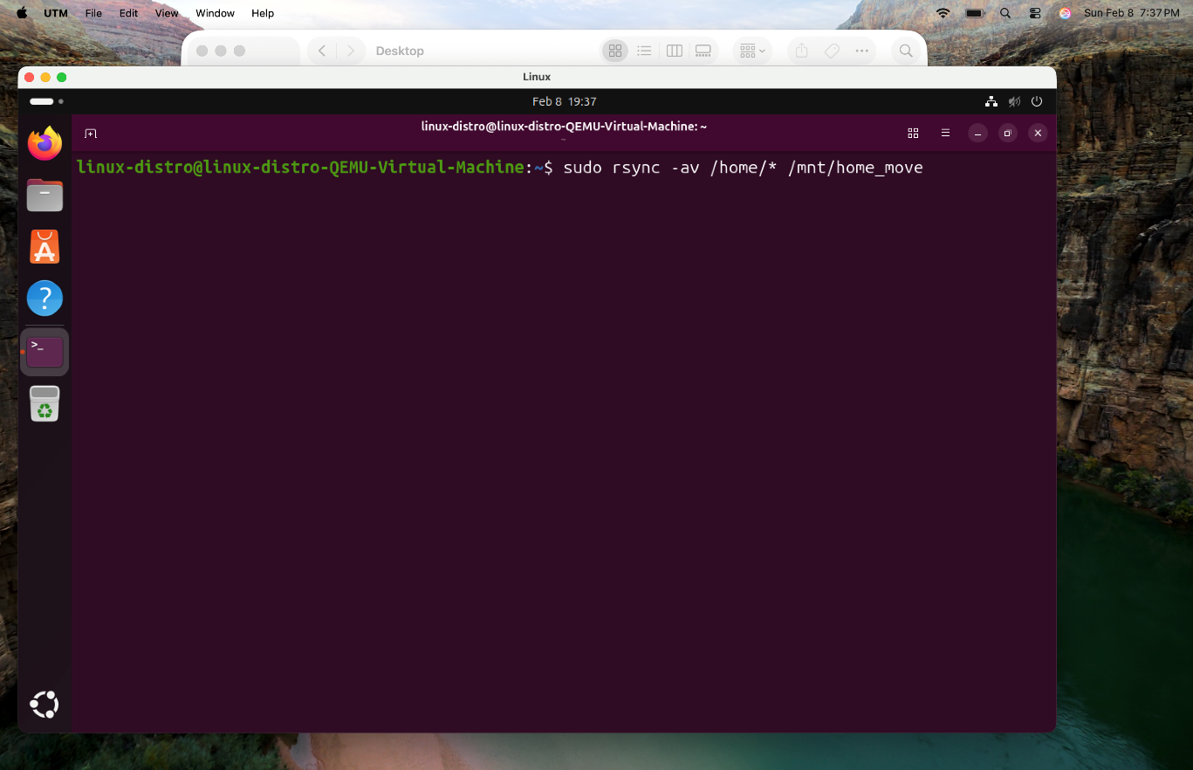

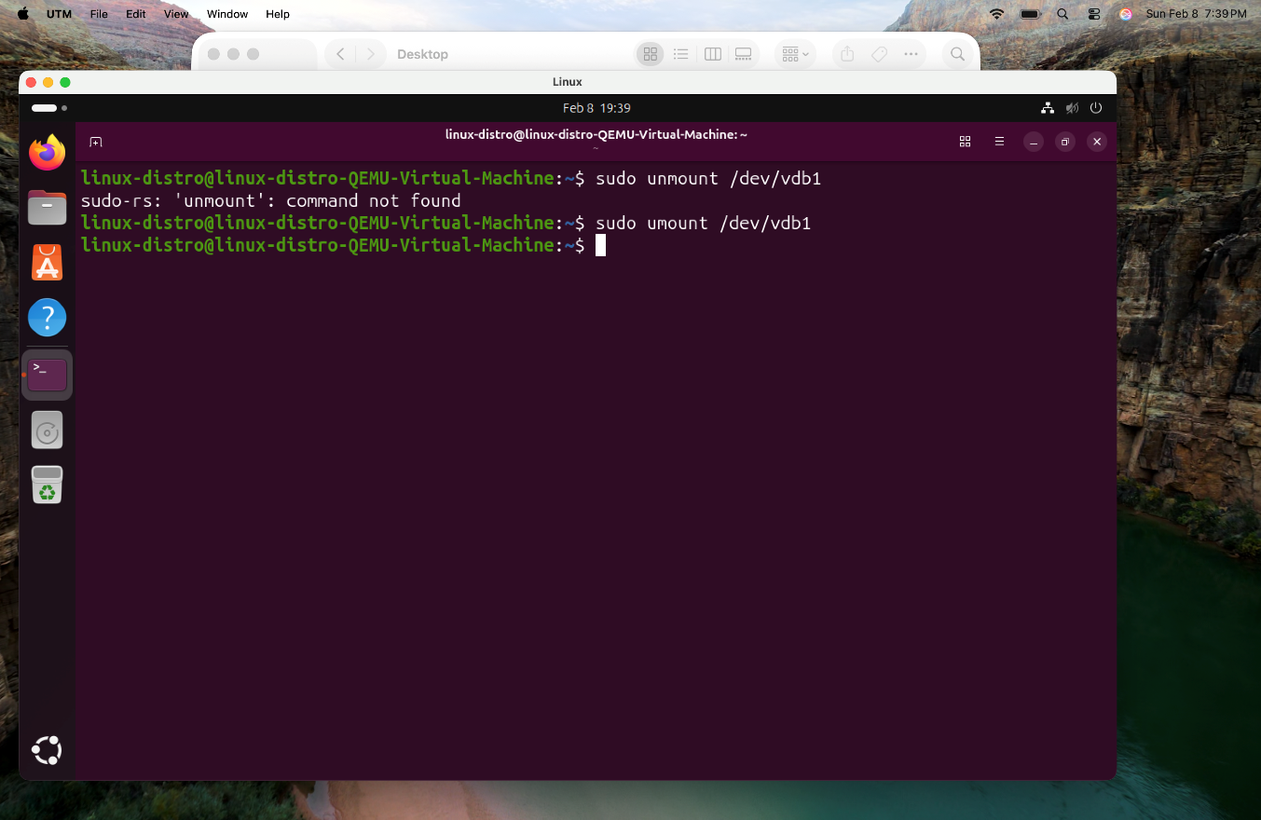

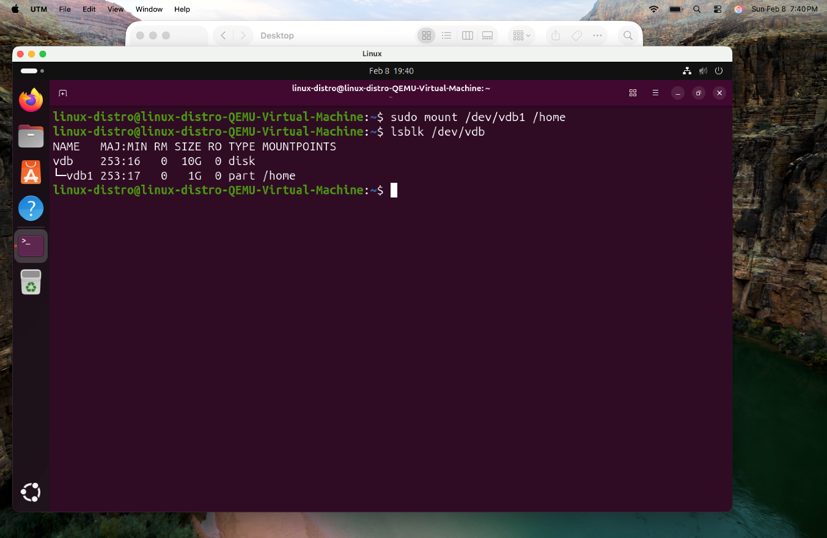

**Action #4:** Startup security.

I will try to verify migration with df -h, and I am going to secure my system configuration by creating a backup of the filesystem table with sudo cp /etc/fstab /etc/fstab_old. Finally, I will be using the nano editor to add a permanent entry for /dev/vdb1 into /etc/fstab, ensuring that my new dedicated home partition automatically mounts every time the system starts up.

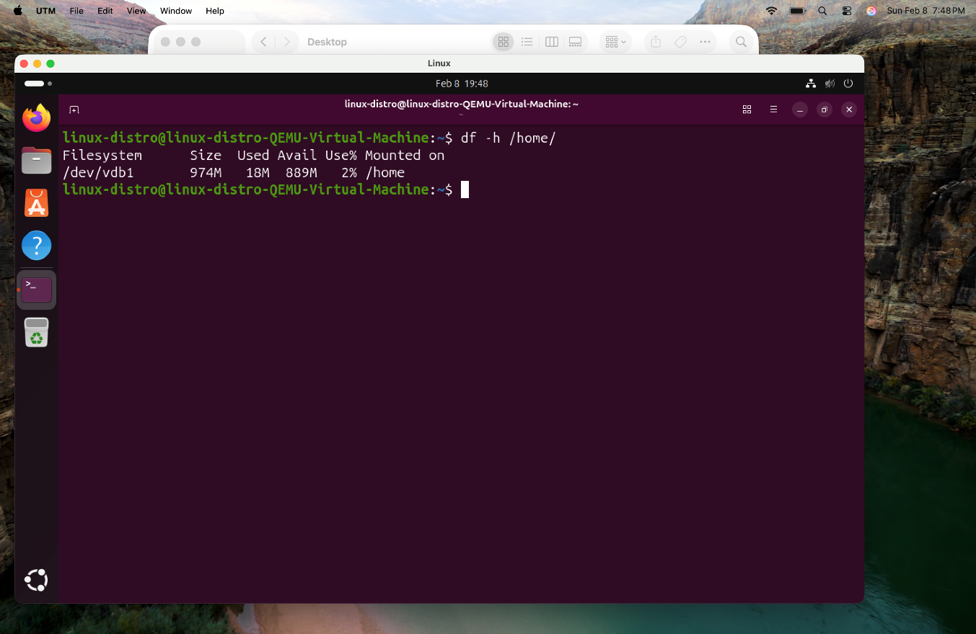

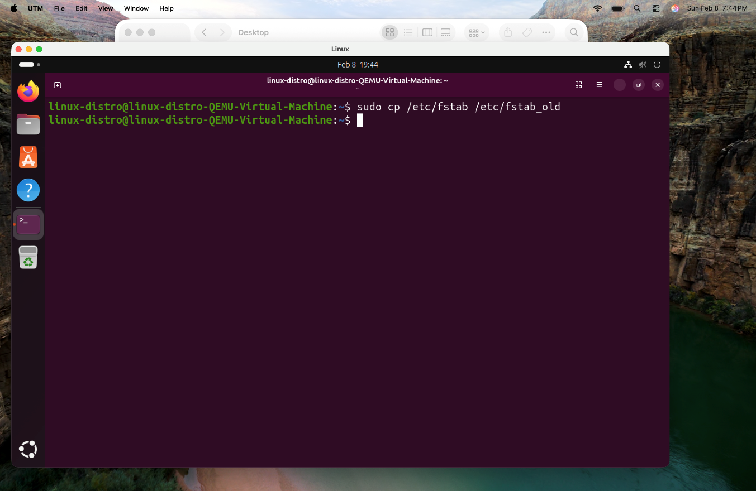

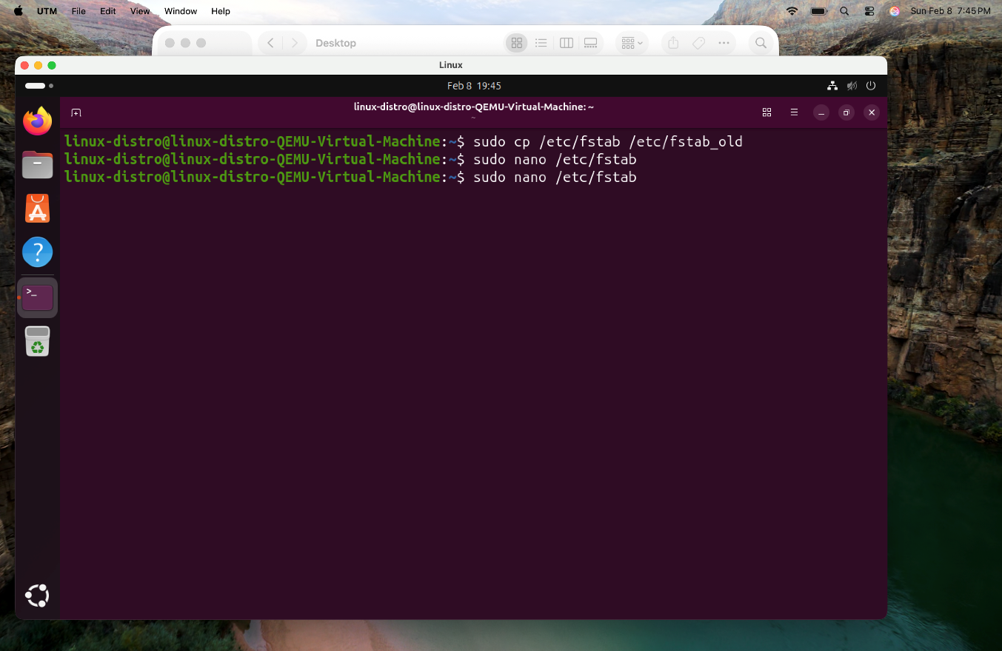

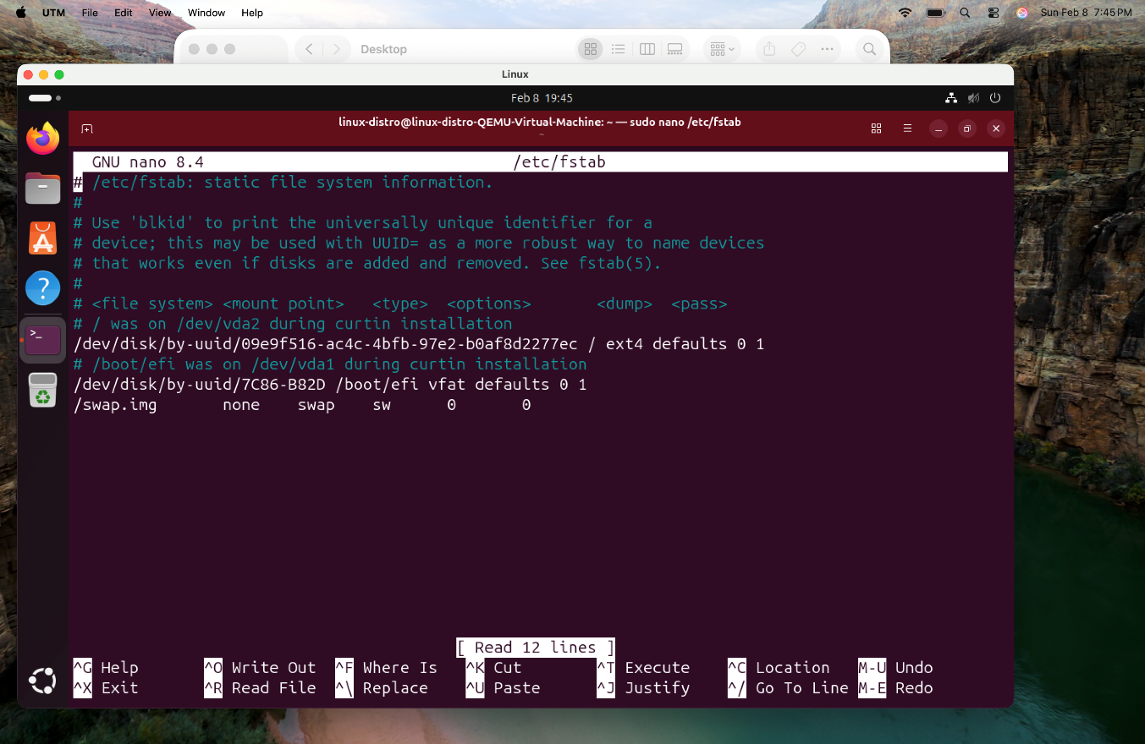

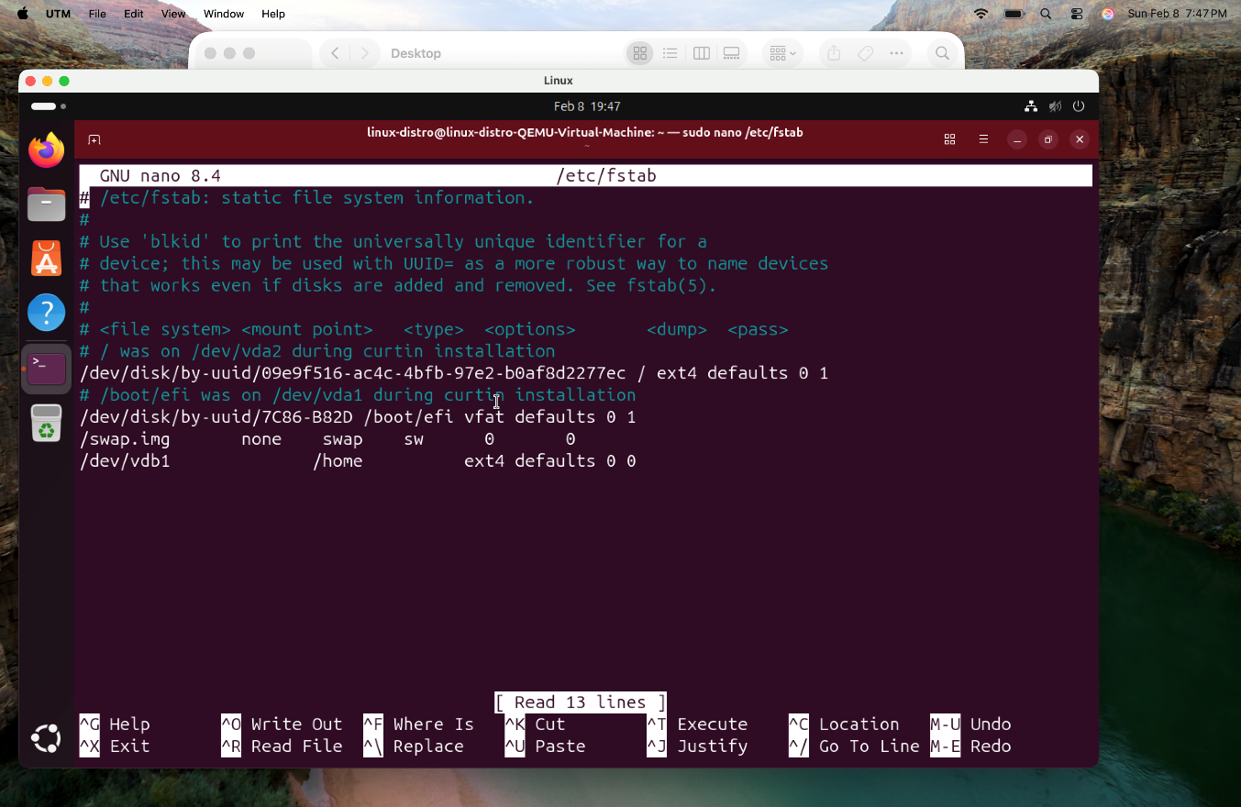

**Action #5:** Shared Library Management.

In this action, I will be investigating the system's dynamic library management by checking the configuration files in /etc/ld.so.conf.d/ and use the ldconfig -p command to view the list of mapped shared libraries.If I locate the rpm binary using whereis command, I will execute ldd -v /usr/bin/ to perform an analysis of how that specific program interacts with the system's software libraries.

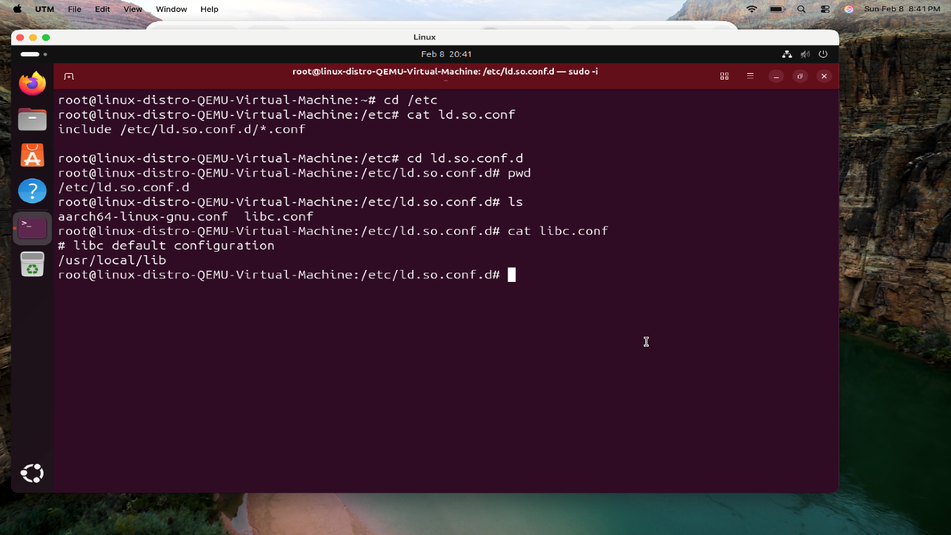

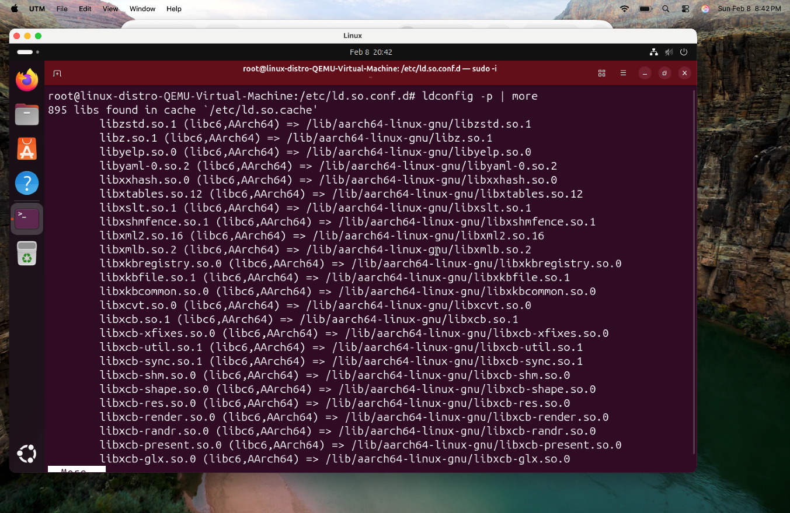

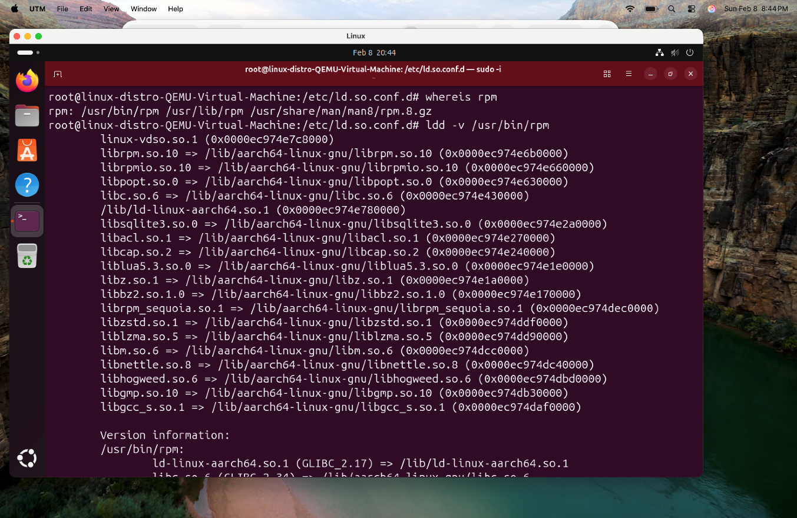

In summary, I have taken several steps to make my computer much better at handling files and keeping my data safe. First, I changed how the storage is set up by using LVMtool. This basically turns my hard drive into a flexible pool of space, so if I ever run out of room for my apps or movies, I can easily grow the size of those areas without having to delete anything or start over. I also updated the system to use UUIDs, which are unique ID numbers for every piece of hardware. This means even if I plug in a new drive or move things around, the computer will always find exactly where my files are located without getting confused.

I also put a lot of focus on protecting my personal information. I moved my home directory which holds all my photos, documents, and settings to its own private section of the disk. This way, if the main system has a problem, my personal files stay safe and are easier to back up automatically. To keep the whole system secure from the moment I turned it on, I took strict safety measures to my startup files. These rules stop people from trying to trick the computer into running dangerous programs from my storage. Finally, I cleaned up the way the computer handles shared program files to improve the systems speed. This project has given me a solid, professional setup that I can rely on as I continue improving my Linux skills.